**MEDIA ADVISORY**



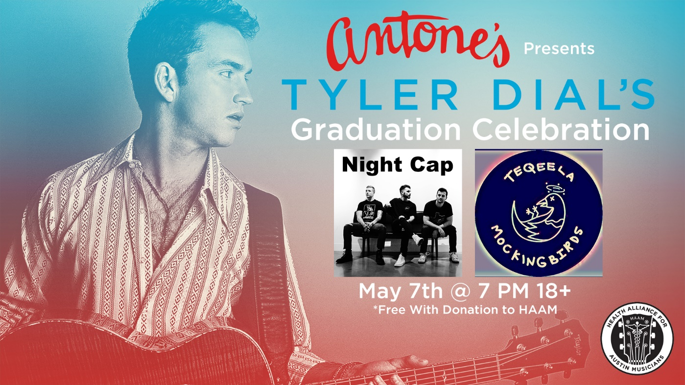

**WHO: Country singer and graduating Longhorn**, [**Tyler Dial**](http://www.tylerdial.com), and **fellow senior bands** [**Night Cap**](https://www.nightcapatx.com/) and[**Teqeela Mockingbirds**](https://www.teqeelamockingbirds.com)

**WHAT: A Graduation Kick-Off, new music debut, and thank you to Austin and UT for four great years of support** – benefiting the [**Health Alliance for Austin Musicians (HAAM).**](https://myhaam.org/)

**The event** will be a sneak preview debut of music from Tyler’s upcoming May 25 EP release and one more chance to have a *Damn Good Time*! Follow Tyler on [**Instagram**](http://www.instagram.com/tylerdial/)**,** [**Twitter**](https://twitter.com/tylerdialmusic) and [**Facebook**](https://www.facebook.com/wolverinepower)for more on the upcoming EP release!

**WHEN: Monday, May 7, 2018** – **7 p.m. to 11 p.m**. CDT

Doors open at 7 p.m. and the event is 18 and over. Admission is free with a donation to HAAM at the door.

**WHERE: The historic** [**Antone's Nightclub**](https://www.antonesnightclub.com/)

305 E. 5th Street

Austin, Texas 78701

**MEDIA** Marcia Scott, Clearwater Communications - 602-451-4550

**CONTACT:** [marcia@AZClearwater.com](mailto:marcia@AZClearwater.com)